Acceptance Test Procedure

Results (SKYDOC-XXXX)

For

Skyryse Flight OS LEMA TPX 325

Software Version: 1918900-DEV

|  |  |  |  |  |
| --- | --- | --- | --- | --- |
| LEMA Assembly Part Number | Operator | Condition | Serial Number | Test Start Time |
| LEMA | Shawn | Engineering | 004 | 3/9/2023 11:38:43 AM |

|  |  |  |
| --- | --- | --- |
| **Full test results:** | **Fail** | |
|  | | |
| **Group** | **Pass/Fail** | |
| **6.1. Visual Examination of the Product** | Pass | |
| **6.2 Weight** | Pass | |
| 6.3 Bonding | Fail | |
| **6.4 Resistance** and Inductance Test **(motor and solenoid)** | Fail | Fail |
| **6.5 Power ON UUT Checks** | Pass | |
| **6.6 Functional Check Out** | Pass | |
| **6.6.3 Holding Load Test** | Fail | Fail |
| **6.6.4 Brake Release Test** | Pass | |
| **6.6.5 N1 and N2 Extend Mechanical Stops and MCE Rigging** | Fail | |
| **6.6.6 N1 and N2 Stroke Check** | Fail | |
| **6.6.7 Performance Test – unloaded operation (one channel operation)** | Fail | |
| **6.6.8 Performance Test – Loaded Operation** | Fail | |
| **6.6.9 Backlash** | Fail | |

**6.1. Visual Examination of the Product**

|  |  |
| --- | --- |
| UUT conforms to the requirements of paragraph 6.1 | Pass |

**6.2 Weight**

|  |  |  |
| --- | --- | --- |
| **Requirements** | **Results** | |
| UUT weight should not exceed 10 lbs | actual weight 9.12 lbs | Unhandled Type: Void |

6.3 Bonding

**Bonding resistance:**

|  |  |  |  |  |  |
| --- | --- | --- | --- | --- | --- |
| **Requirements** | | | **Results** | | |
|  | **Expected** | **Tolerance** | **Simplex** | **Duplex** | **Units** |
| Motor End Cap | 10 | 0.5 | 10 | 10.1 | (mOhms) |
| Solenoid housing | 10 | 0.5 | 9.9 | 10.2 | (mOhms) |
| Encoder cover | 7.5 | 0.5 | 9.8 | 10.3 | (mOhms) |
| All Bonding Pass/Fail | | | Fail | |  |

**6.4 Resistance and Inductance Test** **(motor and solenoid)**

**Resistances:**

|  |  |  |  |  |  |  |
| --- | --- | --- | --- | --- | --- | --- |
| **Requirements** | | | **Results** | | | |
| Pins | **Expected** | **Tolerance** | **Connector J1** | **Connector J2** | **Connector J3** | **Units** |
| E to F | 0.212 | 0.0212 | 0.2 | 0.201 | 0.204 | (Ohms) |
| F to G | 0.212 | 0.0212 | 0.21 | 0.202 | 0.205 | (Ohms) |
| G to E | 0.212 | 0.0212 | 0.22 | 0.203 | 0.206 | (Ohms) |
| A to L | 6.55 | 0.44 | 1 | 2 | 55 | (Ohms) |
| G,F,E,A,L tied together to chassis grounds. Apply 500VDC | 5000000 | 0 | 9E+6 | 1E+7 | 1E+9 | (Ohms) |
| All Resistances Pass/Fail | | | Fail | | |  |

**Inductances:**

|  |  |  |  |  |  |  |  |
| --- | --- | --- | --- | --- | --- | --- | --- |
| **Requirements** | | | | **Results** | | | |
|  | | **Expected** | **Tolerance** | **Connector J1** | **Connector J2** | **Connector J3** | **Units** |
| E to F | 0.155 | | 0.02325 | 2 | 7 | 0.01 | (mH) |
| F to G | 0.155 | | 0.02325 | 0.1 | 25 | 0.4 | (mH) |
| G to E | 0.155 | | 0.02325 | 1 | 0.6 | 2 | (mH) |
| A to L | 22 | | 3.3 | 24 | 23 | 26 | (mH) |
| All Inductances Pass/Fail | | | | Fail | | |  |

**6.5 Power ON UUT Checks**

Confirm all sensors are reporting nominal values and no faults reported

|  |  |  |  |
| --- | --- | --- | --- |
| **Description** | **Results** | | |
| **Sensor** | **Value** | **Units** | **Pass/Fail** |
| Motor 1 | 0.0000 | Inches | Pass |
| Motor 2 | 0.0000 | Inches | Pass |
| Motor 3 | -0.0025 | Inches | Pass |
| M1 | 0.0000 | Inches | Pass |
| M2 | 0.0000 | Inches | Pass |
| M3 | 0.0000 | Inches | Pass |
| Faults 1 | 1024 | Code | Pass |
| Faults 2 | 1024 | Code | Pass |
| Faults 3 | 1024 | Code | Pass |

**6.6 Functional Check Out**

**6.6.1 MCE1, MCE 2, MCE3 Power Up**

|  |  |  |  |  |
| --- | --- | --- | --- | --- |
| **Requirements** | **Results** | | | |
| **Description** | **Ballnut position** | **Units** | **Pass/Fail** | |
| MCE 1 reports values for Ballnut position and motor current | 0 | in | Ballnut Position | Current |
| Pass | Pass |
| (Simulated) FCC/reports values for M1(QPS) | -0 | in | Pass |  |
| MCE 2 reports values for Ballnut position and motor current | 0 | in | Pass | Pass |
| (Simulated) FCC/reports values for M2(QPS) | -0 | in | Pass |  |
| MCE 3 reports values for Ballnut position and motor current | -0.0028 | in | Pass | Pass |
| (Simulated) FCC/reports values for M3(QPS) | -0 | in | Pass |  |

**6.6.3 Holding Load Test**

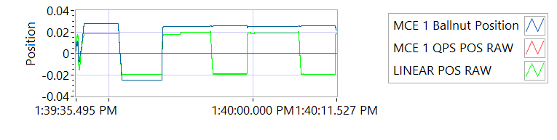

Figure -Hold Brake OFF for MCE 1

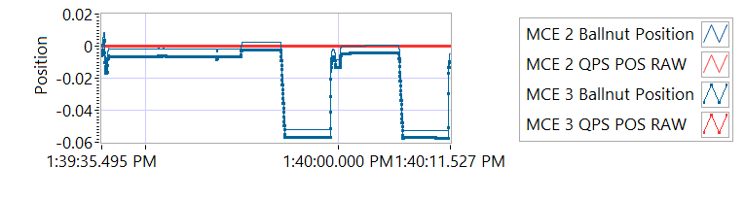

Figure -Hold Brake OFF for MCE 2

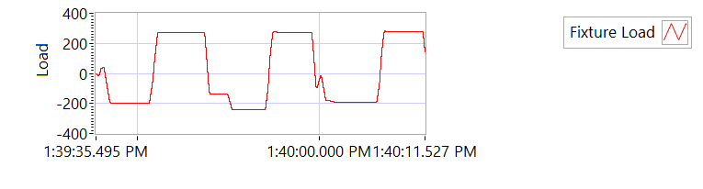

Figure -Hold Brake OFF for MCE 3

**6.6.3.1 Brake OFF, LEMA Output Locked**

|  |  |  |  |  |
| --- | --- | --- | --- | --- |
| **Requirements** | | **Results** | | |
| **MCE** | **Expected Output Force/Amps** | **Actual Output force/Amps** | **Units** | **Output force/Amps, Pass/Fail** |
| MCE 1, 6.6.3.1.1 step d/e– extend 0.2 in Sustain 12.6 Amps (TBC) current limit for 3-5 seconds | 325-800 | -195.5039 | lbf | Failed |
| 12.6 | 6.0012 | Amps | Pass |
| MCE 1, 6.6.3.1.1 step f/g - retract 0.2 in Sustain 12.6 Amps (TBC) current limit for 3-5 seconds | 325-800 | 272.2367 | lbf | Failed |
| 12.6 | -5.9929 | Amps | Pass |
| MCE 2, 6.6.3.1.2 step d/e– extend 0.2 in Sustain 12.6 Amps (TBC) current limit for 3-5 seconds | 325-800 | -241.7329 | lbf | Failed |
| 12.6 | 6.002 | Amps | Pass |
| MCE 2, 6.6.3.1.2 step f/g - retract 0.2 in Sustain 12.6 Amps (TBC) current limit for 3-5 seconds | 325-800 | 272.9577 | lbf | Failed |
| 12.6 | -6.0032 | Amps | Pass |
| MCE 3, 6.6.3.1.3 step d/e– extend 0.2 in Sustain 12.6 Amps (TBC) current limit for 3-5 seconds | 325-800 | -189.249 | lbf | Failed |
| 12.6 | 6.006 | Amps | Pass |
| MCE 3, 6.6.3.1.3 step f/g - retract 0.2 in Sustain 12.6 Amps (TBC) current limit for 3-5 seconds | 325-800 | 278.9383 | lbf | Failed |
| 12.6 | -6.0004 | Amps | Pass |

**6.6.3.2 Brake ON, LEMA Output Free**

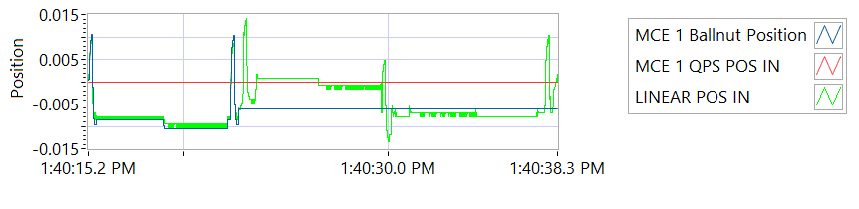

Figure -Hold Brake ON for MCE 1

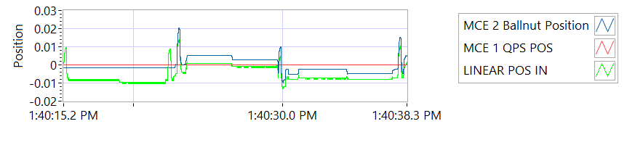

Figure -Hold Brake ON for MCE 2

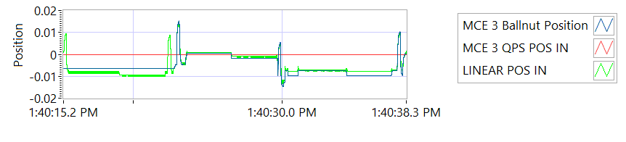

Figure -Hold Brake ON for MCE 3

|  |  |  |  |  |  |  |
| --- | --- | --- | --- | --- | --- | --- |
| **Requirements** | **Results** | | | | | |
| **12.6 +- TBD Amps for 3-5 sec** | | | |  | | |
| **MCE** | **MCE Current** | **Units** | **Current Pass/Fail** | **Position feedback** | **Units** | **Position Feedback Pass/Fail** |
| MCE 1, 6.7.8.2.1 step I – extend 0.2 in | 5.9996 | A | Pass | -0.0087 | in | Pass |
| MCE 1, 6.7.8.2.1 step k - retract 0.2 in | -6.0141 | A | True | -0.0094 | in | Pass |
| MCE 2, 6.7.8.2.2 6.7.8.2.3 step i – extend 0.2 in | 5.9979 | A | True | 0.0008 | in | Pass |
| MCE 2, m step k - retract 0.2 in | -5.9977 | A | True | -0.0008 | in | Pass |
| MCE 3 m step i– extend 0.2 in | 5.9934 | A | True | -0.0071 | in | Pass |
| MCE 3 m step k - retract 0.2 in | -6.0039 | A | True | -0.0079 | in | Pass |

**6.6.4 Brake Release Test**

**Step d –** LEMA reaches commanded position

|  |  |  |  |  |  |
| --- | --- | --- | --- | --- | --- |
| **Requirements** | | | **Results** | | |
| Description | Expected | Tolerance | Position | Units | Pass/Fail |
| MCE1 /Motor 1 | 0.4 |  | 0.4 | in | Pass |
| MCE2 /Motor 2 | 0.4 |  | 0.4 | in | Pass |
| MCE3 /Motor 3 | 0.4 |  | 0.4 | in | Pass |

**6.6.5 N1 and N2 Extend Mechanical Stops and MCE Rigging**

**Step 6.6.5.1** **Extend using M1/N1**

|  |  |  |  |
| --- | --- | --- | --- |
| **Requirements** | **Results** | | |
| **Description** | **Value** | **Units** | **Pass/Fail** |
| N1 extend stop engaged (M1 current saturated) | 1024 | Code | Pass |
| MCE 1 Motor Current 4.5 +/- 0.15 Amps | 5.9919 | Amps | Failed |
| Linear Encoder Value | 0.0653 | in | Pass |
| N1 is Rigged | 0 | Code | Pass |

**Step 6.6.5.2** **Extend using M2/N2**

|  |  |  |  |
| --- | --- | --- | --- |
| **Requirements** | **Results** | | |
| **Description** | **Value** | **Units** | **Pass/Fail** |
| N2 extend stop engaged (M2 current saturated) | 1024 | Code | Pass |
| MCE2 Motor Current 4.5 +/- 0.15 Amps | 6.0007 | Amps | Failed |
| Linear Encoder Value | 0.0244 | in | Pass |
| N2 (Motor 2) is Rigged | 0 | Code | Pass |
| N2 (Motor 3) is Rigged | 0 | Code | Pass |

**6.6.6 N1 and N2 Stroke Check**

|  |  |  |  |
| --- | --- | --- | --- |
| **Requirements** | **Results** | | |
| **Pin to pin Length is 16.732 +/- TBD (ins)** | **Pin to Pin Length** | **Units** | **Pass/Fail** |
|  | in |  |
| **Description** | **Actual Position N1/N2** |  | **Pass/Fail** |
| N2 at -0.575 ins from Null using M2 | -0.575 | in | Pass |
| N1 at +1.725 ins from Null using M1 | 1.725 | in | Pass |
| N1 at -0.575 ins from Null using M1 | -0.575 | in | Pass |
| N2 at +1.725 ins from NULL using M2 | 1.725 | in | Pass |
| N1 at -0.575 ins from Null using M1 | -0.575 | in | Pass |
| N2 at +1.725 ins from Null using M3 | 1.7253 | in | Pass |
| N2 at -0.575 ins from Null using M3 | -0.5731 | in | Pass |

MOTOR 1

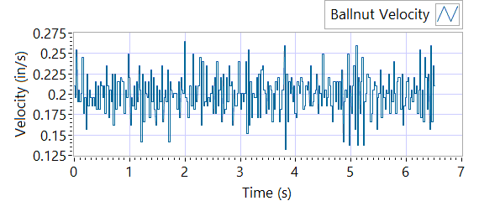

Figure - Ballnut Velocity for Motor One

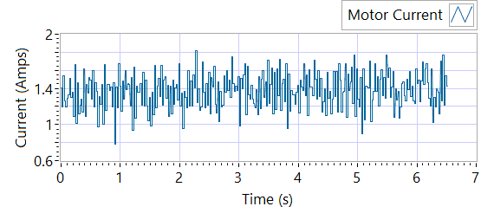

Figure -Current for Motor One

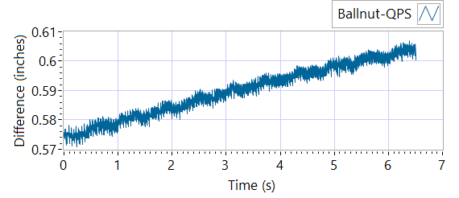

Figure - M1 Delta for Motor One

|  |  |  |  |  |  |  |
| --- | --- | --- | --- | --- | --- | --- |
| **Requirements** | | | **Results** | | | |
| **Description** | **Expected** | **Tolerance** | **Actual Average** | **Peak Velocity** | **Units** | **Pass/Fail** |
| Constant Velocity | 0.2 | 0.02 | 0.2006 | 0.2643 | In/s | Failed |
| **Description** | **Expected** | **Tolerance** | **Actual** | **Standard Deviation** | **Units** | **Pass/Fail** |
| Delta between Motor 1 Position and M1 position | 0.1 | 0.2 | 1.5998 | 0.0089 | in | Failed |
| Delta between Motor 1 Position and Linear Encoder position | 0.1 | 0.2 | 0.607 | 0.3761 | in | Failed |
| Motor Current |  |  | 1.37 | 0.1938 | Amps |  |

|  |  |  |  |  |  |
| --- | --- | --- | --- | --- | --- |
| **Requirements** | | | **Results** | | |
| **Description** | **Expected Difference from Test rig encoder** | **Tolerance** | **Difference from Test rig encoder** | **Units** | **Pass/Fail** |
| Motor 1 position + Motor 2 position = test rig encoder | 0 | 0.1 | 0.0148 | in | Pass |
| Motor1 position + Motor 3 position = test rig encoder | 0 | 0.1 | 0.0148 | in | Pass |
| M1 position + M2 position = test rig encoder | 0.1 | 0.1 | -0.3605 | in | Failed |
| M1 position + M3 position = test rig encoder | 0 | 0.1 | -0.3606 | in | Failed |
| Difference between Motor 2 position and Motor 3 position is < TBD ins | 0 | 0.1 | 0 | in | Pass |
| Difference between M2 position and M3 position is < TBD ins | 0 | 0 | 0.0001 | in | Pass |
| Difference between Motor 1 position and M1 position is < TBD ins | 0 | 0.1 | 0.9503 | in | Failed |
| Difference between Motor 2 position and M2 position is < TBD ins | 0 | 0.1 | 0.575 | in | Failed |
| Difference between Motor 3 position and M3 position is < TBD ins | 0 | 0.1 | 0.5749 | in | Failed |

MOTOR 2

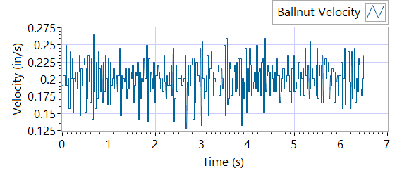

Figure - Ballnut Velocity for Motor Two

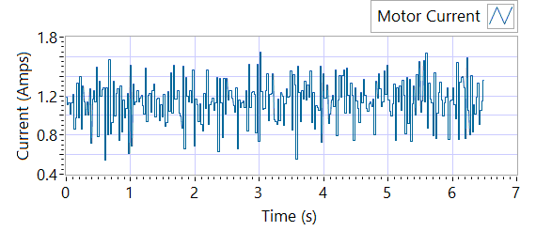

Figure -Current for Motor Two

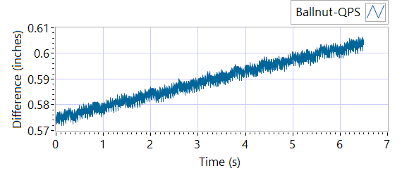

Figure - M1 Delta for Motor Two

|  |  |  |  |  |  |
| --- | --- | --- | --- | --- | --- |
| **Requirements** | | | **Results** | | |
| **Description** | **Expected Difference from Test rig encoder** | **Tolerance** | **Difference from Test rig encoder** | **Units** | **Pass/Fail** |
| Motor 1 position + Motor 2 position = test rig encoder | 0 | 0.1 | 0.0144 | in | Pass |
| Motor1 position + Motor 3 position = test rig encoder | 0 | 0.1 | 0.0144 | in | Pass |
| M1 position + M2 position = test rig encoder | 0.1 | 0.1 | -0.3453 | in | Failed |
| M1 position + M3 position = test rig encoder | 0 | 0.1 | -0.3454 | in | Failed |
| Difference between Motor 2 position and Motor 3 position is < TBD ins | 0 | 0.1 | 0.0012 | in | Pass |
| Difference between M2 position and M3 position is < TBD ins | 0 | 0 | 0.0001 | in | Pass |
| Difference between Motor 1 position and M1 position is < TBD ins | 0 | 0.1 | 0.575 | in | Failed |
| Difference between Motor 2 position and M2 position is < TBD ins | 0 | 0.1 | 0.9348 | in | Failed |
| Difference between Motor 3 position and M3 position is < TBD ins | 0 | 0.1 | 0.9349 | in | Failed |

|  |  |  |  |  |  |  |
| --- | --- | --- | --- | --- | --- | --- |
| **Requirements** | | | **Results** | | | |
| **Description** | **Expected** | **Tolerance** | **Actual Average** | **Peak Velocity** | **Units** | **Pass/Fail** |
| Constant Velocity | 0.2 | 0.02 | 0.2 | 0.2643 | In/s | Failed |
| **Description** | **Expected** | **Tolerance** | **Actual** | **Standard Deviation** | **Units** | **Pass/Fail** |
| Delta between Motor 2 Position and M2 position | 0.1 | 0.2 | 1.5958 | 0.0086 | Inches | Failed |
| Delta between Motor 2 Position and Linear Encoder position | 0.1 | 0.2 | 0.6061 | 0.3747 | Inches | Failed |
| Motor Current |  |  | 1.1421 | 0.2149 | Amps |  |

MOTOR 3

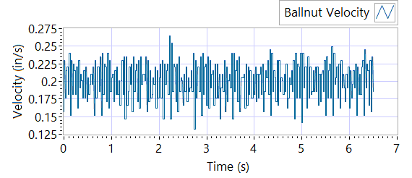

Figure - Ballnut Velocity for Motor Three

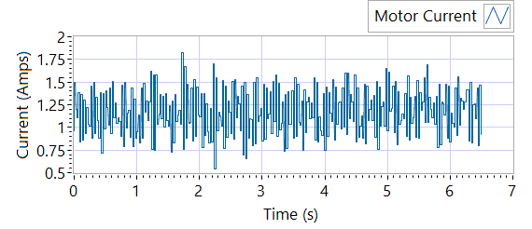

Figure -Current for Motor Three



Figure - M3 Delta for Motor Three

|  |  |  |  |  |  |  |
| --- | --- | --- | --- | --- | --- | --- |
| **Requirements** | | | **Results** | | | |
| **Description** | **Expected** | **Tolerance** | **Actual Average** | **Peak Velocity** | **Units** | **Pass/Fail** |
| Constant Velocity | 0.2 | 0.02 | 0.2 | 0.2643 | In/s | Failed |
| **Description** | **Expected** | **Tolerance** | **Actual** | **Standard Deviation** | **Units** | **Pass/Fail** |
| Delta between Motor 3 Position and M3 position | 0.1 | 0.2 | 1.5833 | 0.0087 | in | Failed |
| Delta between Motor 3 Position and Linear Encoder position | 0.1 | 0.2 | 0.6065 | 0.3753 | in | Failed |
| Motor Current |  |  | 1.169 | 0.2558 | Amps |  |

|  |  |  |  |  |  |
| --- | --- | --- | --- | --- | --- |
| **Requirements** | | | **Results** | | |
| **Description** | **Expected Difference from Test rig encoder** | **Tolerance** | **Difference from Test rig encoder** | **Units** | **Pass/Fail** |
| Motor 1 position + Motor 2 position = test rig encoder | 0 | 0.1 | 0.0144 | in | Pass |
| Motor1 position + Motor 3 position = test rig encoder | 0 | 0.1 | 0.0143 | in | Pass |
| M1 position + M2 position = test rig encoder | 0.1 | 0.1 | -0.3597 | in | Failed |
| M1 position + M3 position = test rig encoder | 0 | 0.1 | -0.3598 | in | Failed |
| Difference between Motor 2 position and Motor 3 position is < TBD ins | 0 | 0.1 | 0.0021 | in | Pass |
| Difference between M2 position and M3 position is < TBD ins | 0 | 0 | 0.0001 | in | Pass |
| Difference between Motor 1 position and M1 position is < TBD ins | 0 | 0.1 | 0.575 | in | Failed |
| Difference between Motor 2 position and M2 position is < TBD ins | 0 | 0.1 | 0.949 | in | Failed |
| Difference between Motor 3 position and M3 position is < TBD ins | 0 | 0.1 | 0.9491 | in | Failed |

**6.6.7 Performance Test – unloaded operation (one channel operation)**

**6.6.7.1.1 MCE 1 - Step Response Test**

**The result for motor one is shown below:**

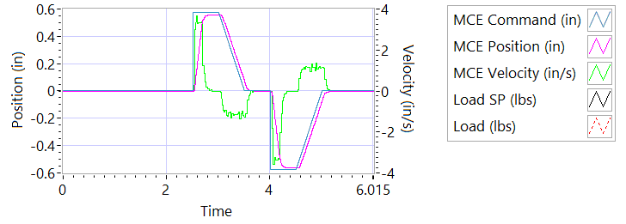

Figure - Results for Motor One

**Step d Extension**

|  |  |  |  |
| --- | --- | --- | --- |
| **Requirements** | **Results** | | |
| **Description** | **Actual Speed / Time** | **Units** | **Pass/Fail** |
| No Load speed is 2.7 to 3.3 in/sec | 3.2231 | In/s | True |
| Time to achieve 80% of the specified stroke (+ 0.575 ins) is 170+9/-9 ms seconds | 191 | miliseconds | Failed |

**Step e Retraction**

|  |  |  |  |
| --- | --- | --- | --- |
| **Requirements** | **Results** | | |
| **Description** | **Actual Speed / Time** | **Units** | **Pass/Fail** |
| No Load speed is 2.7 to 3.3 in/sec | -3.2879 | In/s | Failed |
| Time to achieve 80% of the specified stroke (- 0.575 ins) is 170+9/-9 ms seconds | 197 | miliseconds | Failed |

**6.6.7..1.2 MCE 1 - Frequency Response**

**Step d**

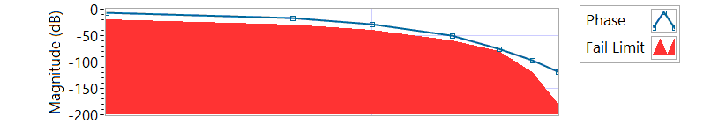

Figure - Phase for Motor One

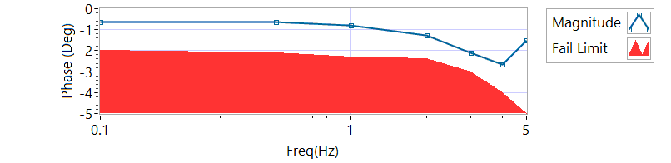

Figure - Magnitude for Motor One

**Frequency Response**

|  |  |  |  |  |
| --- | --- | --- | --- | --- |
| **Frequency**  **(Hz)** | **Magnitude**  **(dB)** | **Phase**  **(deg)** | **Max Phase**  **Allowance (deg)** | **Pass/Fail** |
| 0.1 Hz | -0.642865 | -5.85 | -20 | Pass |
| 0.5 Hz | -0.642865 | -15.966 | -30 | Pass |
| 1 Hz | -0.776385 | -28.296 | -40 | Pass |
| 2 Hz | -1.25265 | -50.688 | -60 | Pass |
| 3 Hz | -2.11522 | -74.304 | -80 | Pass |
| 4 Hz | -2.64828 | -96.912 | -120 | Pass |
| 5 Hz | -1.50343 | -118.44 | -180 | Pass |

6.6.7.2.1 **MCE 2 - Step Response Test**

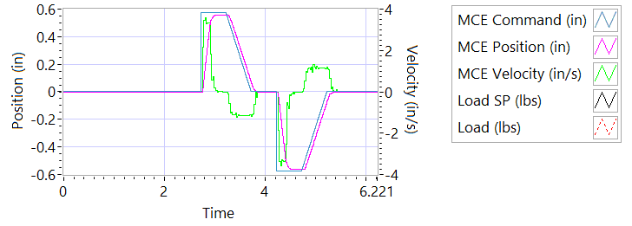

Figure - Results for Motor Two

**Step d Extension**

|  |  |  |  |
| --- | --- | --- | --- |
| **Requirements** | **Results** | | |
| **Description** | **Actual Speed / Time** | **Units** | **Pass/Fail** |
| No Load speed is 2.7 to 3.3 in/sec | 3.2777 | In/s | Pass |
| Time to achieve 80% of the specified stroke (+ 0.575 ins) is 170+9/-9 ms seconds | 198 | milliseconds | Failed |

**Step e Retraction**

|  |  |  |  |
| --- | --- | --- | --- |
| **Requirements** | **Results** | | |
| **Description** | **Actual Speed / Time** | **Units** | **Pass/Fail** |
| No Load speed is 2.7 to 3.3 in/sec | -3.2661 | In/s | Failed |
| Time to achieve 80% of the specified stroke (- 0.575 ins) is 170+9/-9 ms seconds | 199 | milliseconds | Failed |

6.6.7.2.2 **MCE 2 - Frequency Response Test**

**Step d**

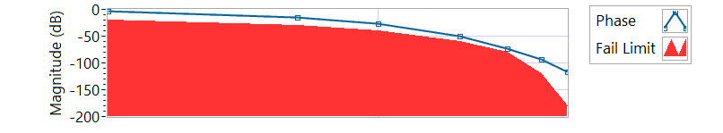

Figure - Phase for Motor Two

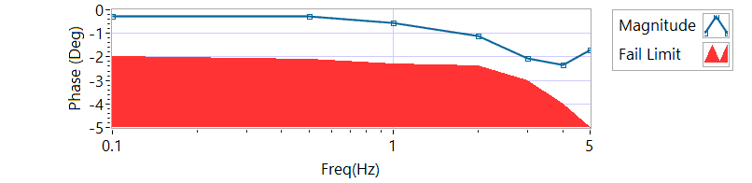

Figure - Magnitude for Motor Two

**Frequency Response**

|  |  |  |  |  |
| --- | --- | --- | --- | --- |
| **Frequency (Hz)** | **Magnitude**  **(db)** | **Phase**  **(Deg)** | **Max Phase**  **Allowance (Deg)** | **Pass/Fail** |
| 0.1 Hz | -0.282405 | -3.3516 | -20 | Pass |
| 0.5 Hz | -0.282405 | -14.364 | -30 | Pass |
| 1 Hz | -0.569567 | -25.92 | -40 | Pass |
| 2 Hz | -1.09614 | -49.968 | -60 | Pass |
| 3 Hz | -2.06306 | -72.576 | -80 | Pass |
| 4 Hz | -2.35535 | -92.736 | -120 | Pass |
| 5 Hz | -1.72154 | -117 | -180 | Pass |

6.6.7.3.1 **MCE 3 – Step Response Test**

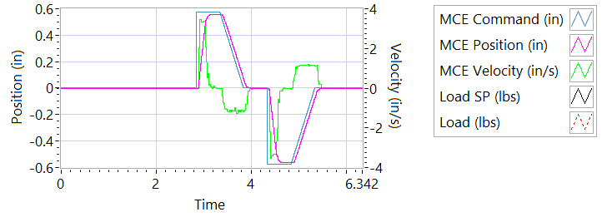

Figure - Results for Motor Three

**Step d Extension**

|  |  |  |  |
| --- | --- | --- | --- |
| **Requirements** | **Results** | | |
| **Description** | **Actual Speed / Time** | **Units** | **Pass/Fail** |
| No Load speed is 2.7 to 3.3 in/sec | 3.2623 | In/s | Pass |
| Time to achieve 80% of the specified stroke (+ 0.575 ins) is 170+9/-9 ms seconds | 209 | milliseconds | Failed |

**Step e Retraction**

|  |  |  |  |
| --- | --- | --- | --- |
| **Requirements** | **Results** | | |
| **Description** | **Actual Speed / Time** | **Units** | **Pass/Fail** |
| No Load speed is 2.7 to 3.3 in/sec | -3.2469 | In/s | Failed |
| Time to achieve 80% of the specified stroke (- 0.575 ins) is 170+9/-9 ms seconds | 205 | milliseconds | Failed |

6.6.7.3.2 **MCE 3 Frequency Response Test**

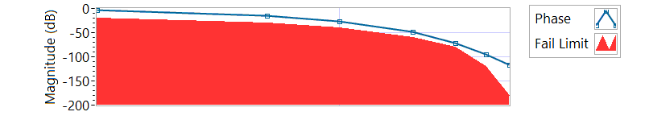

Figure - Phase for Motor Three

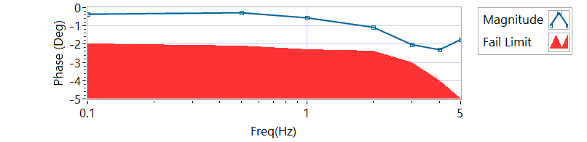

Figure - Magnitude for Motor Three

**Step d**

|  |  |  |  |  |
| --- | --- | --- | --- | --- |
| **Frequency**  **(Hz)** | **Magnitude**  **(dB)** | **Phase**  **(Deg)** | **Max Phase**  **Allowance (Deg)** | **Pass/Fail** |
| 0.1 Hz | -0.353307 | -3.5856 | -20 | Pass |
| 0.5 Hz | -0.296539 | -14.328 | -30 | Pass |
| 1 Hz | -0.569567 | -26.244 | -40 | Pass |
| 2 Hz | -1.06518 | -49.104 | -60 | Pass |
| 3 Hz | -2.02845 | -71.928 | -80 | Pass |
| 4 Hz | -2.28838 | -94.176 | -120 | Pass |
| 5 Hz | -1.72953 | -115.92 | -180 | Pass |

**6.6.8 Performance Test – Loaded Operation**

6.6.8.1 **Step and Frequency Response Test - Loaded**

6.6.8.1.1 **MCE1 – Step Response Test**

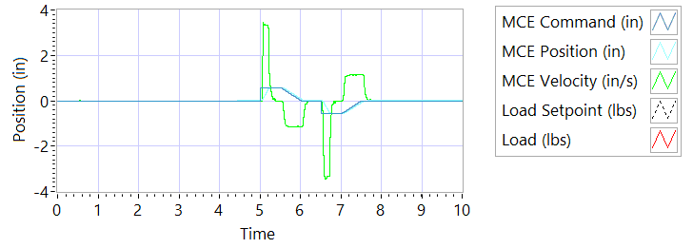

Figure - Results for Motor One Loaded

Step response Test

**Step j – 225 lbf tension - Extension**

|  |  |  |  |
| --- | --- | --- | --- |
| **Requirements** | **Results** | | |
| **Description** | **Actual Speed / Time** | **Units** | **Pass/Fail** |
| No Load speed is 2.7 to 3.3 in/sec | 3.2448 | In/s | Pass |
| Time to achieve 80% of the specified stroke (+ 0.575 ins) is 170+9/-9 ms seconds | 201 | milliseconds | Failed |

**Step k – 225 lbf tension - Retraction**

|  |  |  |  |
| --- | --- | --- | --- |
| **Requirements** | **Results** | | |
| **Description** | **Actual Speed / Time** | **Units** | **Pass/Fail** |
| No Load speed is 2.7 to 3.3 in/sec | -3.2978 | In/s | Failed |
| Time to achieve 80% of the specified stroke (- 0.575 ins) is 170+9/-9 ms seconds | 203 | milliseconds | Failed |

**Step n – 225 lbf compression - Extension**

|  |  |  |  |
| --- | --- | --- | --- |
| **Requirements** | **Results** | | |
| **Description** | **Actual Speed / Time** | **Units** | **Pass/Fail** |
| No Load speed is 2.7 to 3.3 in/sec | 3.2865 | In/s | Pass |
| Time to achieve 80% of the specified stroke (+0.575 ins) is 170+9/-9 ms seconds | 206 | milliseconds | Failed |

**Step o – 225 lbf compression - Retraction**

|  |  |  |  |
| --- | --- | --- | --- |
| **Requirements** | **Results** | | |
| **Description** | **Actual Speed / Time** | **Units** | **Pass/Fail** |
| No Load speed is 2.7 to 3.3 in/sec | -3.2433 | In/s | Failed |
| Time to achieve 80% of the specified stroke (-0.575 ins) is 170+9/-9 ms seconds | 195 | milliseconds | Failed |

6.6.8.1.2 **MCE 1 – Frequency Response Test**

**Step d – 225 lbf Tension**

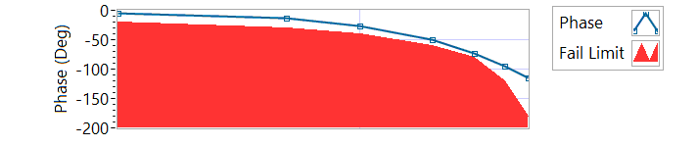

Figure - Phase for Motor One Loaded Tension

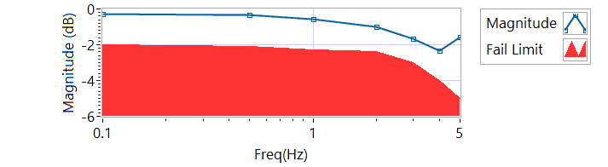

Figure - Magnitude for Motor One Loaded Tension

|  |  |  |  |  |
| --- | --- | --- | --- | --- |
| **Frequency**  **(Hz)** | **Magnitude**  **(dB)** | **Phase**  **(Deg)** | **Max Phase**  **Allowance (Deg)** | **Pass/Fail** |
| 0.1 HZ | -0.268292 | -4.23 | -20 | Pass |
| 0.5 HZ | -0.324878 | -13.518 | -30 | Pass |
| 1 HZ | -0.56957 | -25.956 | -40 | Pass |
| 2 HZ | -1.01894 | -49.536 | -60 | Pass |
| 3 HZ | -1.68977 | -72.9 | -80 | Pass |
| 4 HZ | -2.34839 | -94.464 | -120 | Pass |
| 5 HZ | -1.57749 | -115.38 | -180 | Pass |

**Step h – 225 lbf Compression**

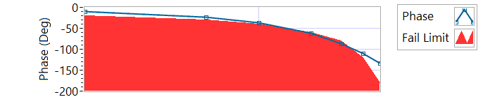

Figure - Phase for Motor One Loaded Compression

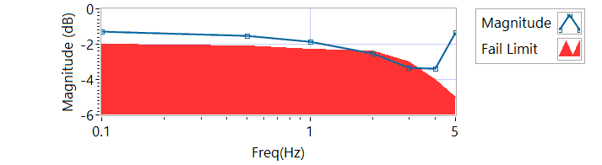

Figure - Magnitude for Motor One Loaded Compression

|  |  |  |  |  |
| --- | --- | --- | --- | --- |
| **Frequency**  **(Hz)** | **Magnitude**  **(dB)** | **Phase**  **(Deg)** | **Max Phase**  **Allowance (Deg)** | **Pass/Fail** |
| 0.1 HZ | -1.28429 | -10.7352 | -20 | Pass |
| 0.5 HZ | -1.50908 | -22.554 | -30 | Pass |
| 1 HZ | -1.85756 | -36.54 | -40 | Pass |
| 2 HZ | -2.54434 | -62.136 | -60 | Failed |
| 3 HZ | -3.34025 | -86.94 | -80 | Failed |
| 4 HZ | -3.37323 | -110.736 | -120 | Pass |
| 5 HZ | -1.35422 | -133.74 | -180 | Pass |

6.6.8.2.1 **MCE 2 – Step Response Test**

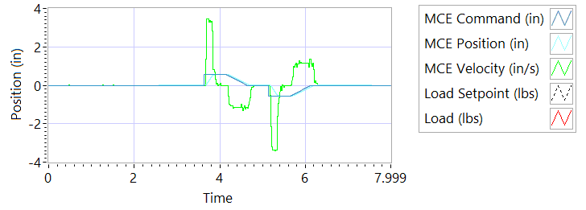

Figure - Results for Motor Two Loaded Tension

**Step j – 225 lbf tension - Extension**

|  |  |  |  |
| --- | --- | --- | --- |
| **Requirements** | **Results** | | |
| **Description** | **Actual Speed / Time** | **Units** | **Pass/Fail** |
| No Load speed is 2.7 to 3.3 in/sec | 3.2453 | In/s | Pass |
| Time to achieve 80% of the specified stroke (+ 0.575 ins) is 170+9/-9 ms seconds | 201 | milliseconds | Failed |

**Step k – 225 lbf tension - Retraction**

|  |  |  |  |
| --- | --- | --- | --- |
| **Requirements** | **Results** | | |
| **Description** | **Actual Speed / Time** | **Units** | **Pass/Fail** |
| No Load speed is 2.7 to 3.3 in/sec | -3.3044 | In/s | Failed |
| Time to achieve 80% of the specified stroke (- 0.575 ins) is 170+9/-9 ms seconds | 212 | milliseconds | Failed |

**Step n – 225 lbf compression - Extension**

|  |  |  |  |
| --- | --- | --- | --- |
| **Requirements** | **Results** | | |
| **Description** | **Actual Speed / Time** | **Units** | **Pass/Fail** |
| No Load speed is 2.7 to 3.3 in/sec | 3.3228 | In/s | Failed |
| Time to achieve 80% of the specified stroke (+0.575 ins) is 170+9/-9 ms seconds | 213 | milliseconds | Failed |

**Step o – 225 lbf compression - Retraction**

|  |  |  |  |
| --- | --- | --- | --- |
| **Requirements** | **Results** | | |
| **Description** | **Actual Speed / Time** | **Units** | **Pass/Fail** |
| No Load speed is 2.7 to 3.3 in/sec | -3.2212 | In/s | Failed |
| Time to achieve 80% of the specified stroke (-0.575 ins) is 170+9/-9 ms seconds | 200 | milliseconds | Failed |

6.6.8.2.2 **MCE 2 – Frequency response Test**

**Step d – 225 lbf Tension**

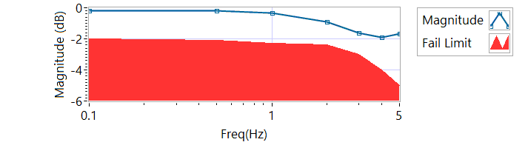

Figure - Magnitude for Motor Two Loaded Tension

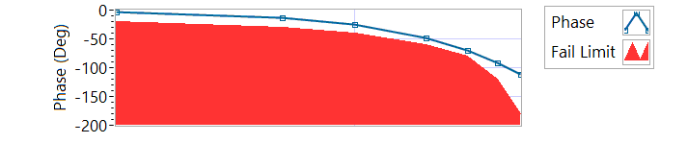

Figure - Phase for Motor Two Loaded Tension

|  |  |  |  |  |
| --- | --- | --- | --- | --- |
| **Frequency**  **(Hz)** | **Magnitude**  **(dB)** | **Phase**  **(Deg)** | **Max Phase**  **Allowance (Deg)** | **Pass/Fail** |
| 0.1 HZ | -0.184095 | -3.186 | -20 | Pass |
| 0.5 HZ | -0.170144 | -12.564 | -30 | Pass |
| 1 HZ | -0.339079 | -24.516 | -40 | Pass |
| 2 HZ | -0.927183 | -47.88 | -60 | Pass |
| 3 HZ | -1.60713 | -70.092 | -80 | Pass |
| 4 HZ | -1.88737 | -92.16 | -120 | Pass |
| 5 HZ | -1.65727 | -111.06 | -180 | Pass |

**Step h – 225 lbf Compression**

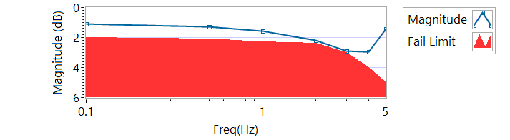

Figure - Magnitude for Motor Two Loaded Compression

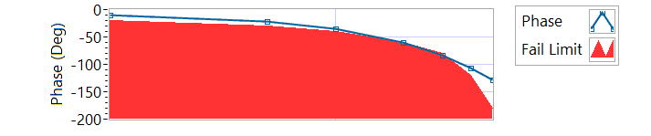

Figure - Phase for Motor Two Loaded Compression

|  |  |  |  |  |
| --- | --- | --- | --- | --- |
| **Frequency**  **(Hz)** | **Magnitude**  **(dB)** | **Phase**  **(Deg)** | **Max Phase**  **Allowance (Deg)** | **Pass/Fail** |
| 0.1 HZ | -1.11167 | -10.1664 | -20 | Pass |
| 0.5 HZ | -1.26846 | -21.924 | -30 | Pass |
| 1 HZ | -1.59079 | -34.92 | -40 | Pass |
| 2 HZ | -2.1678 | -59.472 | -60 | Pass |
| 3 HZ | -2.91662 | -83.16 | -80 | Failed |
| 4 HZ | -2.95464 | -105.84 | -120 | Pass |
| 5 HZ | -1.43698 | -128.52 | -180 | Pass |

6.6.8.3.1 **MCE 3 – Step Response Test**

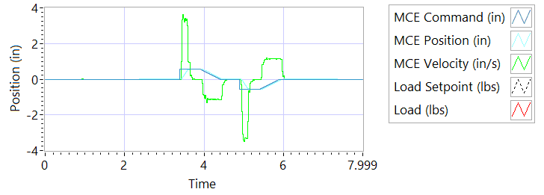

Figure - Results for Motor Three

**Step j – 225 lbf tension - Extension**

|  |  |  |  |
| --- | --- | --- | --- |
| **Requirements** | **Results** | | |
| **Description** | **Actual Speed / Time** | **Units** | **Pass/Fail** |
| No Load speed is 2.7 to 3.3 in/sec | 3.2456 | In/s | Pass |
| Time to achieve 80% of the specified stroke (+ 0.575 ins) is 170+9/-9 ms seconds | 194 | milliseconds | Failed |

**Step k – 225 lbf tension - Retraction**

|  |  |  |  |
| --- | --- | --- | --- |
| **Requirements** | **Results** | | |
| **Description** | **Actual Speed / Time** | **Units** | **Pass/Fail** |
| No Load speed is 2.7 to 3.3 in/sec | -3.311 | In/s | Failed |
| Time to achieve 80% of the specified stroke (- 0.575 ins) is 170+9/-9 ms seconds | 206 | milliseconds | Failed |

**Step n – 225 lbf compression - Extension**

|  |  |  |  |
| --- | --- | --- | --- |
| **Requirements** | **Results** | | |
| **Description** | **Actual Speed / Time** | **Units** | **Pass/Fail** |
| No Load speed is 2.7 to 3.3 in/sec | 3.3044 | In/s | Failed |
| Time to achieve 80% of the specified stroke (+0.575 ins) is 170+9/-9 ms seconds | 206 | milliseconds | Failed |

**Step o – 225 lbf compression - Retraction**

|  |  |  |  |
| --- | --- | --- | --- |
| **Requirements** | **Results** | | |
| **Description** | **Actual Speed / Time** | **Units** | **Pass/Fail** |
| No Load speed is 2.7 to 3.3 in/sec | -3.2319 | In/s | Failed |
| Time to achieve 80% of the specified stroke (-0.575 ins) is 170+9/-9 ms seconds | 189 | milliseconds | Failed |

6.6.8.3.2 **MCE 3 – Frequency Response Test**

**Step d – 225 lbf Tension**

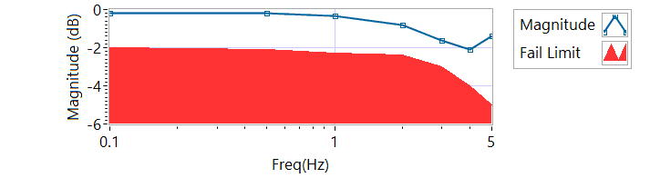

Figure - Magnitude for Motor Three Loaded Tension

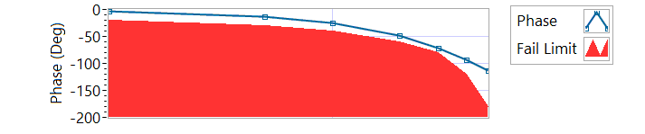

Figure - Phase for Motor Three Loaded Tension

|  |  |  |  |  |
| --- | --- | --- | --- | --- |
| **Frequency**  **(Hz)** | **Magnitude**  **(dB)** | **Phase**  **(Deg)** | **Max Phase**  **Allowance (Deg)** | **Pass/Fail** |
| 0.1 HZ | -0.198071 | -3.0348 | -20 | Pass |
| 0.5 HZ | -0.1841 | -12.762 | -30 | Pass |
| 1 HZ | -0.353311 | -24.768 | -40 | Pass |
| 2 HZ | -0.821352 | -48.312 | -60 | Pass |
| 3 HZ | -1.60713 | -70.848 | -80 | Pass |
| 4 HZ | -2.08426 | -93.168 | -120 | Pass |
| 5 HZ | -1.38582 | -113.76 | -180 | Pass |

**Step h – 225 lbf Compression**

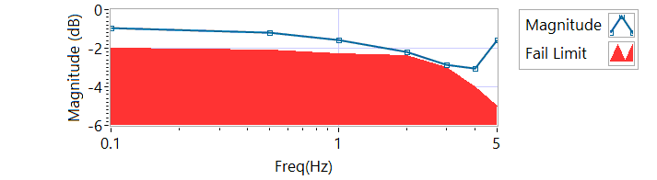

Figure - Magnitude for Motor Three Loaded Compression

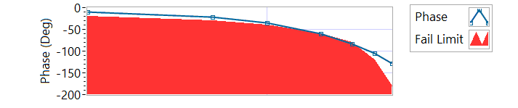

Figure - Phase for Motor Three Loaded Compression

|  |  |  |  |  |
| --- | --- | --- | --- | --- |
| **Frequency**  **(Hz)** | **Magnitude**  **(dB)** | **Phase**  **(Deg)** | **Max Phase**  **Allowance (Deg)** | **Pass/Fail** |
| 0.1 HZ | -0.972938 | -9.6408 | -20 | Pass |
| 0.5 HZ | -1.20541 | -21.33 | -30 | Pass |
| 1 HZ | -1.57439 | -35.136 | -40 | Pass |
| 2 HZ | -2.1678 | -59.4 | -60 | Pass |
| 3 HZ | -2.85648 | -82.512 | -80 | Failed |
| 4 HZ | -3.02986 | -105.696 | -120 | Pass |
| 5 HZ | -1.54777 | -128.16 | -180 | Pass |

**6.6.9 Backlash**

6.6.9.1 **Simplex Brake 1 – ON; Duplex brake 2 – OFF**

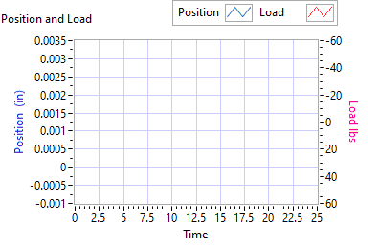

Figure - Backlash Simplex brake 1 On, Duplex brake 2 Off

|  |  |  |  |  |  |  |
| --- | --- | --- | --- | --- | --- | --- |
| **Requirements** | **Results** | | | | | |
| **Load (lbf)** | **Backlash (ins)** | | | **Units** | | **Pass/Fail** |
| Step e +/- 35 lbf tension (motor 2 and motor 3 ZERO position) | 0.0016 | | | in | | Pass |
| Step e +/- 25 lbf compression  (motor 2 and motor 3 ZERO position) | -0.0008 | | | in | | Pass |
| Step g,Total backlash  New units: 0.0144 ins  In Service Units: 0.019 ins | 0 | | | in | | Pass |
| **Requirements** | **Results** | | | | | |
| **All channels feedback signals remain within allowable limits** | **Allowable limit** | **Actual Value** | **Units** | | **Pass/Fail** | |
| Motor 1 Tension | 0.1000 | 0.0000 | in | | Pass | |
| Motor 1 Compression |  |  | in | |  | |
| Motor 2 Tension | 0.1000 | -0.0000 | in | | Pass | |
| Motor 2 Compression |  |  | in | |  | |
| Motor 3 Tension | 0.1000 | 0.0002 | in | | Pass | |
| Motor 3 Compression |  |  | in | |  | |
| M1 Tension | 0.1000 | 0.0000 | in | | Pass | |
| M1 Compression |  |  | in | |  | |
| M2 Tension | 0.1000 | -0.0023 | in | | Pass | |
| M2 Compression |  |  | in | |  | |
| M3 Tension | 0.1000 | -0.0059 | in | | Pass | |
| M3 Compression |  |  | in | |  | |

6.6.9.2**Simplex Brake 1 – OFF; Duplex Brake 2 – ON**

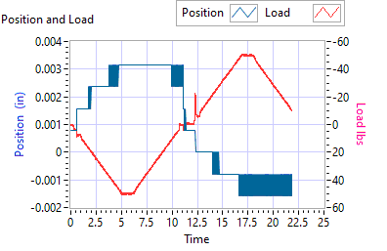

Figure - Backlash Simplex brake 1 Off, Duplex brake 2 On

|  |  |  |  |  |
| --- | --- | --- | --- | --- |
| **Requirements** | **Results** | | | |
| **Load (lbf)** | **Backlash (ins)** | | **Units** | **Pass/Fail** |
| Step e +/- 35 lbf tension  (motor 1 ZERO position) | 0.0031 | | in | Pass |
| Step e +/- 25 lbf compression  (motor 1 ZERO position) | -0.0008 | | in | Pass |
| Step g, Total backlash  New units: 0.0144 ins  In Service Units: 0.019 ins | 0.0016 | | in | Pass |
| **Requirements** | | **Results** | | |
| **All channels feedback signals remain within allowable limits** | **Allowable limit** | **Actual Value** | **Units** | **Pass/Fail** |
| Motor 1 Tension | 0.1000 | 0.0000 | in | Pass |
| Motor 1 Compression |  |  | in |  |
| Motor 2 Tension | 0.1000 | -0.0000 | in | Pass |
| Motor 2 Compression |  |  | in |  |
| Motor 3 Tension | 0.1000 | 0.0002 | in | Pass |
| Motor 3 Compression |  |  | in |  |
| M1 Tension | 0.1000 | 0.0000 | in | Pass |
| M1 Compression |  |  | in |  |
| M2 Tension | 0.1000 | -0.0023 | in | Pass |
| M2 Compression |  |  | in |  |
| M3 Tension | 0.1000 | -0.0059 | in | Pass |
| M3 Compression |  |  | in |  |

6.6.9.3 **Both Brakes OFF**

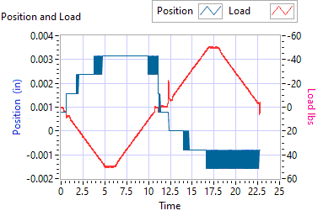

Figure - Backlash Simplex brake 1 Off, Duplex brake 2 Off

|  |  |  |  |  |
| --- | --- | --- | --- | --- |
| **Requirements** | **Results** | | | |
| **Load (lbf)** | **Backlash (ins)** | | **Units** | **Pass/Fail** |
| Step e +/- 35 lbf tension  (motor 1 and motor 2 holding ZERO position) | 0.0031 | | in | Pass |
| Step e +/- 25 lbf compression  (motor 1 and motor 2 holding ZERO position) | 0 | | in | Pass |
| Step g,Total backlash  New units: 0.0144 ins  In Service Units: 0.019 ins | 0.0016 | | in | Pass |
| **Requirements** | **Results** | | | |
| **All channels feedback signals remain within allowable limits** | **Allowable**  **limit** | **Actual Value** | **Units** | **Pass/Fail** |
| Motor 1 Tension | 0.1000 | 0.0000 | in | Pass |
| Motor 1 Compression |  |  | in |  |
| Motor 2 Tension | 0.1000 | -0.0000 | in | Pass |
| Motor 2 Compression |  |  | in |  |
| Motor 3 Tension | 0.1000 | 0.0002 | in | Pass |
| Motor 3 Compression |  |  | in |  |
| M1 Tension | 0.1000 | 0.0000 | in | Pass |
| M1 Compression |  |  | in |  |
| M2 Tension | 0.1000 | -0.0023 | in | Pass |
| M2 Compression |  |  | in |  |
| M3 Tension | 0.1000 | -0.0059 | in | Pass |
| M3 Compression |  |  | in |  |